2.11: Worksheet 2

1. The following questions relate to PEP20. You might want to revisit the video within the pre-session content.
   1. What are the 19 Principles within PEP20?
   2. Which do you think is the easiest to implement?
   3. Which do you think is the most complicated to implement?
2. In addition to PEP8, there are several different rules in relation to valid variable names in Python. Create a list of invalid variable names within Python and put their valid equivalent next to them.
3. Write some code which takes four numbers from the user and calculates their average. The average should be printed to 3 decimal places, using the format command.
4. Write a program that allows a user to enter their two favourite foods. The program should then print out the name of a new food by joining the original food names together with a hyphen. For example:

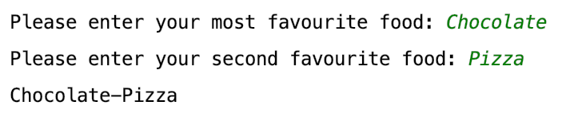

1. Write a Tipper program where the user enters a restaurant bill total. The program should then output three amounts – a 10% tip, a 15% tip, and a 20% tip. Your output should be in pounds.
2. Write a Car Salesman program where the user enters the base price of the car. The program should then ask whether the user wants to add several different extras (including metallic paint, car tax, delivery charge, air con, etc.). The total price of the car should be output in pounds at the end. You can assume that all the additional charges are fixed amounts.
3. Write some code which asks the user their age in years. Your program should then print out how old they are in:
   1. Days
   2. Hours
   3. Minutes
   4. Seconds

You can assume that there are no leap years

1. As a challenge, extend the previous question so that leap years are considered.